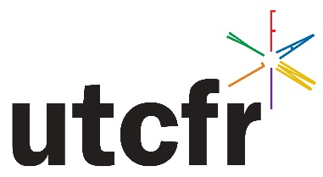

Call for Proposals

Research Papers, Research Posters, and Round Tables for
Utah Council on Family Relations Annual Conference
Weber State University
Ogden, UT
April 1, 2016
Register at: http://utcfr.weebly.com

Submission Deadline: Friday, March 11, 2016

Early submissions receive preferential treatment

We invite faculty, community professionals, graduate students, and undergraduate students to submit proposals for the upcoming conference of the Utah Council on Family Relations to be held April 1, 2016, at Weber State University.

Formats:
(1) Research paper (10-15 minute presentation),
(2) Research poster

Submissions not selected for the research paper category (preferred) will be automatically submitted to the poster format. The 2016 conference theme is “The Future of Family Science.” Preference will be given to proposals aligned with the theme, but research may deal with any family scholarship. Topics may include: family life education; family contexts, structures, and processes; life span and development, couple issues, parenting, family financial management, marriage and family therapy, policy and law, etc.

Our goal is to be inclusive. We hope to receive submissions from established scholars but also graduate and undergraduate students with little or no experience. The poster session will allow participants to get experience presenting at scholarly conferences, and to network.

To submit a proposal, go to http://utcfr.weebly.com (Preferred). Length: 1-2 pages maximum (1 page is preferred). The more precise the better. Alternatively, submit Pamela B. Payne at pamelapayne@weber.edu

Include: (submit at http://utcfr.weebly.com)

1. Title of research

2. Preferred format (Paper or Poster)

3. Author names(s)

4. Contact person (name, affiliation, e-mail, phone)

5. Description of research (limit of two pages)

May include abstract and very brief description of research questions, hypotheses (if applicable), methods, results, discussion, and key references. If research is not yet complete, describe what you plan to do.

